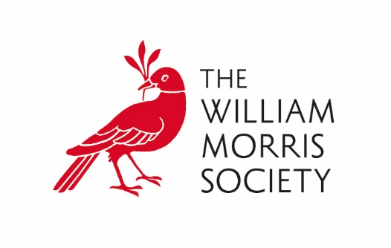
Finance Manager
Part time 1.5 days per week (hybrid working)
Permanent (subject to 6-month probationary period)
Salary £35,000 FTE (pro rata)
Location: The William Morris Society
26 Upper Mall, London, W6 9TA

About the Society
William Morris was a revolutionary force in Victorian Britain. His work dramatically changed the fashions and ideologies of the era and he remains as influential and important today as he was in his own time.
The William Morris Society was founded in 1955 to share knowledge of the life and works of William Morris amongst our members and the wider public.
The Society manages an accredited museum which is based in the Coach House of Kelmscott House, Hammersmith, Morris’s London home for the last eighteen years of his life. We hold an exciting variety of exhibitions, talks and events throughout the year and offer a thriving membership scheme.

About the Role
Reporting directly to the William Morris Society Director, the Finance Manager will be responsible for:
- Manage efficient day to day running of the finance systems and procedures
- Oversee all financial activities for the Society, including accounting, reporting, budgeting, and forecasting.
- Maintaining a system of proactive budgetary control to ensure that all financial expenditure is contained within approved budgets and that any actual or potential over/underspend or income shortfall is reported back promptly to the Director and the Trustees.
- Provision of advice on financial and commercial decisions and financial analysis for business decision making.
- Managing relationships with stakeholders and external auditors.
- Preparation of strategic financial documents such as business plans, long term forecasts and cashflow modelling.
- Developing and maintaining systems and procedures to ensure that the organisation complies with good practice, financial regulations and internal and external audit recommendations.
- Issue invoices in line with agreed schedules of funders, pay invoices received, and oversee the banking of monies received.
- Preparation of monthly bank and other control account reconciliations.
- Maintain accurate financial records using the Society’s agreed software.
- Preparation on a monthly basis of the payroll for all Society employees using the Society’s payroll software including preparation of HMRC tax returns and dealing with staff queries on an ad hoc basis.
- Maintain financial records relating to Gift Aid and preparation and submission of monthly Gift Aid Tax return.
- Compile and prepare the financial information required to support fundraising bids and grant reports.
- Maintenance of Society's insurance policies and co-ordination of all insurance claims.
- Work closely with the Director and Treasurer in preparation of the financial management reports and management of the annual budget.
- Preparation of management accounts/reports for quarterly board meetings.
- Preparation of monthly rolling 12-month cashflow forecasts for the Director and quarterly review by Finance & General Purposes Committee.
- Preparation of Annual Financial Accounts in line with Charity Commission requirements.
- Liaise with the Treasurer and External Independent Examiner/Auditors concerning scrutiny of the Annual Accounts.
- Submit annual return, accounts, trustees and auditor’s reports to the Charity Commission and update Charity Commission records with details of new Trustees
- In conjunction with the Director and the Treasurer ensure that all appropriate returns are made to the Charity Commission.
- Any other duties required by the Director

About you
- be a formally qualified accountant
- have relevant and appropriate experience in finance and management obtained in a complex organisation
- have an ability to work on your own initiative, assess priorities and be proactive
- have an interest in William Morris, museums or history

How to apply
We value diversity and inclusivity and encourage applications from individuals with a range of backgrounds and experiences, including those from underrepresented communities.
Application deadline: 9am, Monday 14th April
Interviews expected to be held: W/C 21st April
Please email your CV and Cover Letter outlining your interest and suitability in this role to Gabriella Esser director@williammorrissociety.org

