Group Visits: William Morris at Home

Private group visits to our museum can be booked for Wednesdays and Fridays throughout the year. These visits include a talk by one of our knowledgeable speakers, which lasts around an hour and covers a brief history of the house, William Morris, his life and work.

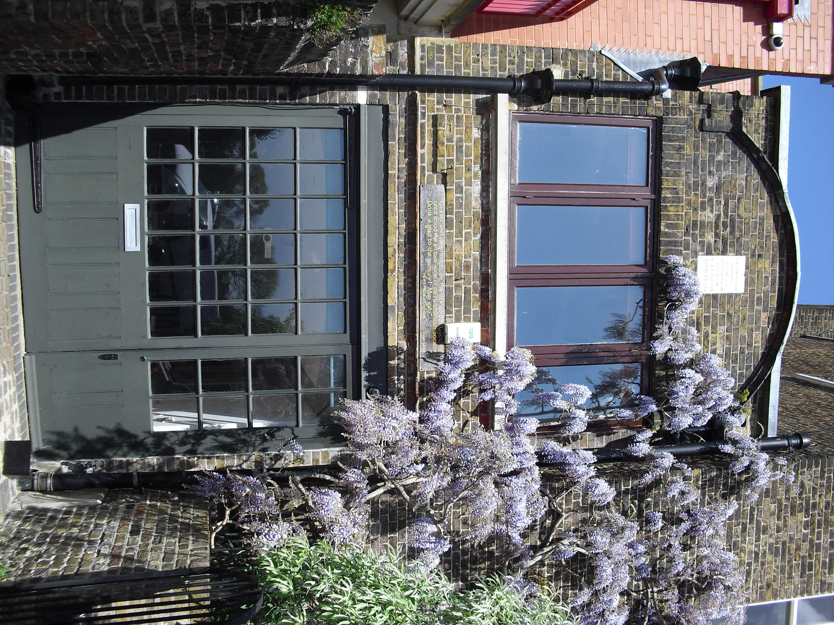Groups will be able to view both the permanent display and any current exhibition, staged in The Coach House at Morris’s final London home. Here Morris hosted many distinguished Socialist League speakers, as well as many of his eminent friends. Our collection includes furniture, wallpapers, textiles and the Albion press used to print the Kelmscott Chaucer. In addition to looking at the Society's premises, a talk with one of our experienced guides involves bringing out items which are not usually on display, including original wallpaper, watercolour designs and other items from our collection.   
If you notify us in advance of any specific interests your group has, we will aim to tailor the talk and items to suit your needs.

The tour and talk costs £12 per person, with a minimum group size of eight people and a maximum of 24.

The William Morris Society's premises are situated in the Coach House and basement of Kelmscott House, 26 Upper Mall, London W6 9TA. The upper floors are tenanted and do not form part of the tour. Entry is via the Coach House.

You may also wish to consider a tour on the same day of the nearby Emery Walker’s House at 7 Hammersmith Terrace (open from March-November inclusive, and an approximate ten-minute walk away). That house has a maximum number of eight visitors at any one time, but if you have larger numbers, it is possible to split a group and swap the two groups over after an hour. Should you wish to include this option, we would liaise with the Emery Walker Trust over the timings, but the costs of the tour of their site would need to be negotiated and settled directly with them. Please contact [info@emerywalker.org.uk](mailto:info@emerywalker.org.uk) for information.

We ask for at least one month’s notice for group visits, and for payment to be made in full in advance. If you are interested in booking a group visit, please email vanessa[@williammorrissociety.org](mailto:admin@williammorrissociety.org) with a selection of possible dates.